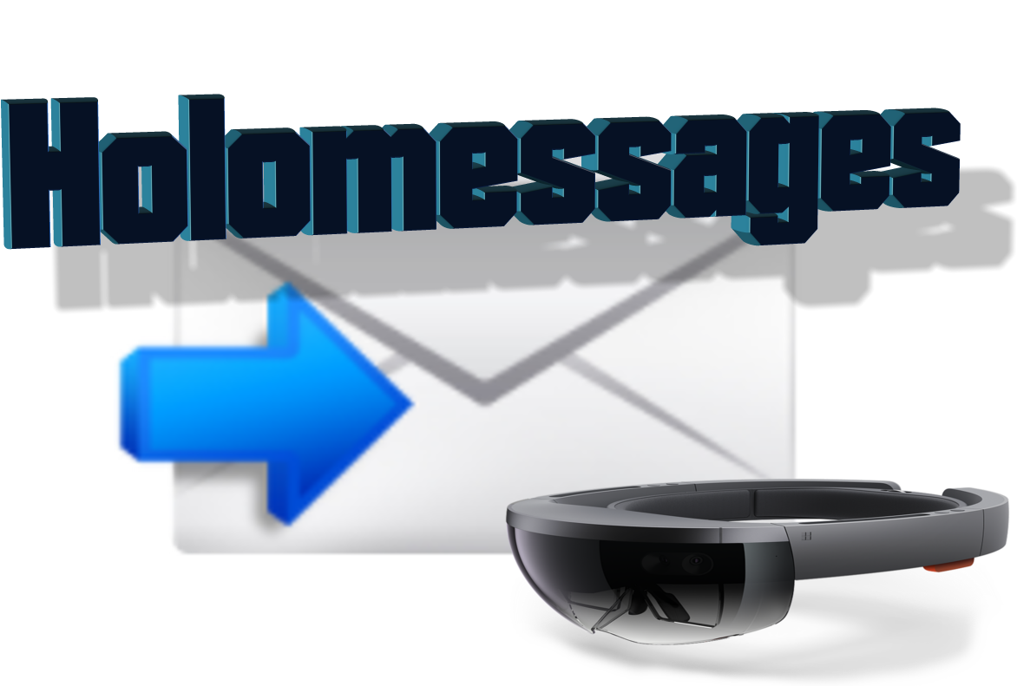

HoloMessages Project
Eran Tzabar
[GIP] | [234329] | [20.4.18]

Table of contents

Page 2 Project Idea
Page 3 Application overview
Page 4 System
Page 7 Features & Screenshots
Page 12 Useful Links

Project idea
HoloMessages is an Augmented Reality system for sending and receiving office messages.
Using the Hololens device by scanning a QR code at the entrance to the office, you can load user information and leave a message.
There are new technologies that enable users to live in a new and interactive Mixed Reality world.
The goal is to provide users a simple and necessary office operation, to send and receive messages and integrate the operations into the new technological world.
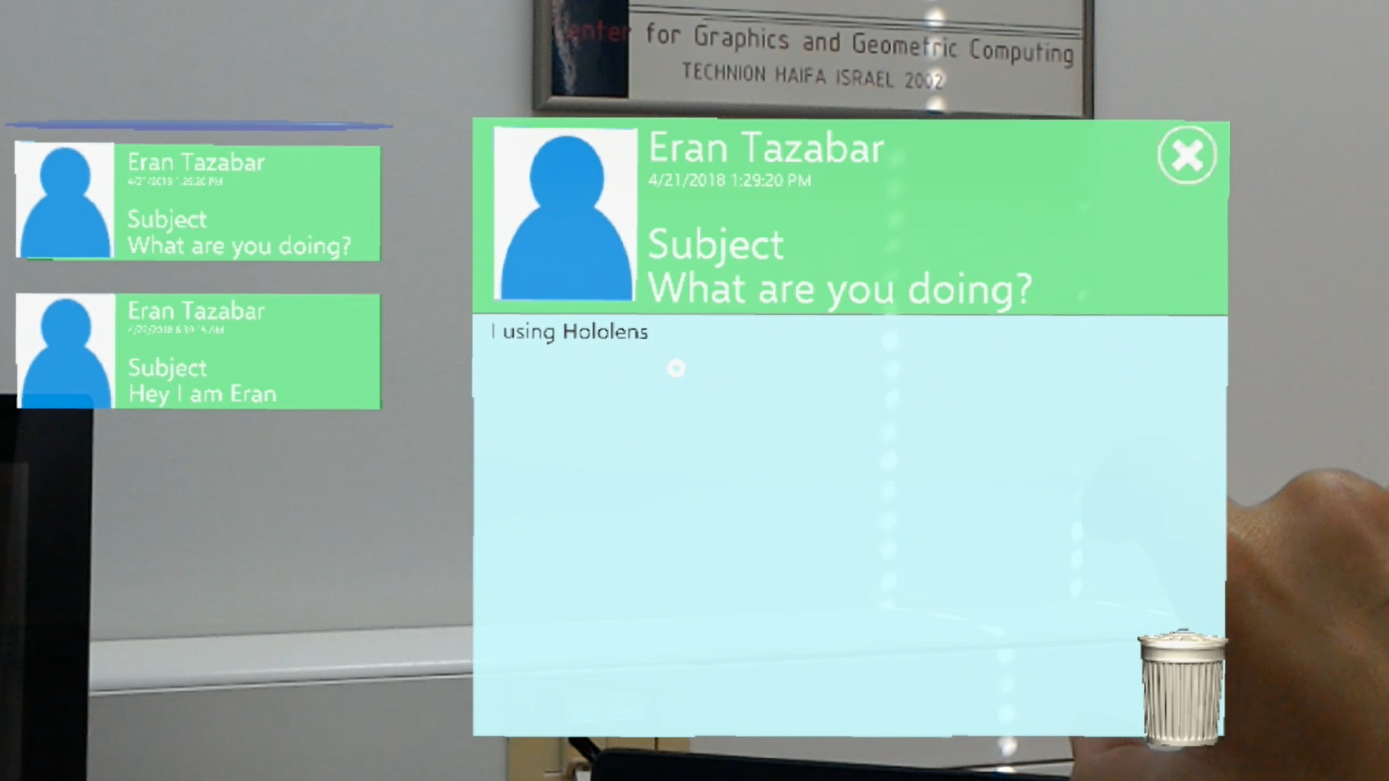
Providing a much more comfortable workplace, which extend your working environment outside of your computer screen to the whole room.
Similar when you put sticky notes on your desks that make an extension of your working environment.

Application overview
The system consists of an application for the Hololens(UWP), an application for a smartphone(Android) and a Server software (Windows), the communication between the components is carried out using a UDP protocol, through ports: 10000,9999.
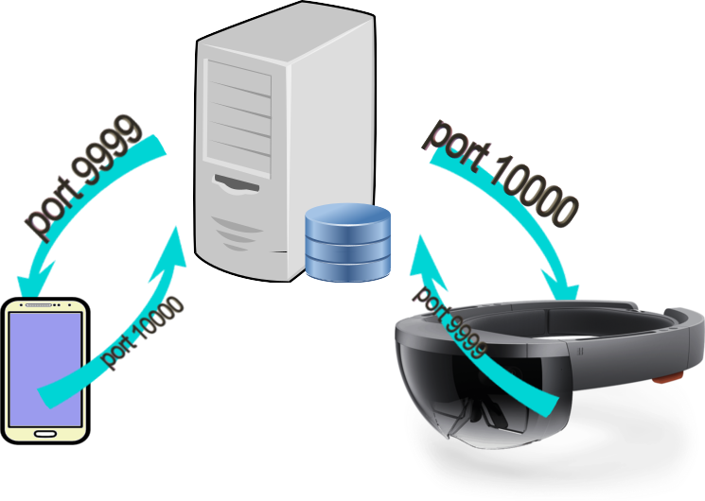

The user can login into the system using the Hololen and its user information at any time and see the messages that are left for him.
Each user can write text messages using a smartphone application ,the smartphone connects and communicates with the Hololens device via server.

The three components were developed in the UNITY 2017.3.0f3 - graphic engine, written in C# in Visual Studio 2017 environment.
*See the next page for more explanation of the System.

System
The system developed in Unity 2017.3.0f3 ,
Unity is a cross-platform game engine developed by Unity Technologies, which is primarily used to develop both high-quality 3D and 2D games, deploy them across mobile, desktop pc, VR/AR consoles or websites.
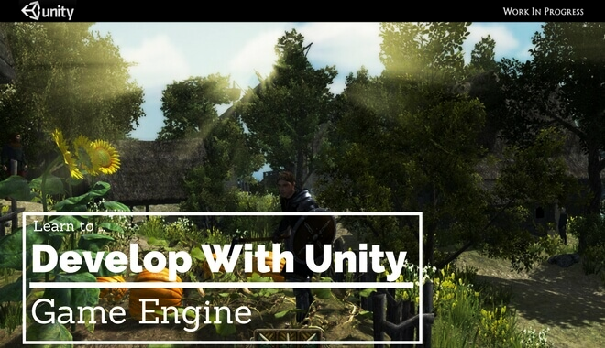

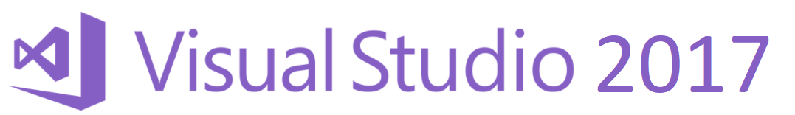
Microsoft Visual Studio is an integrated development environment (IDE) from Microsoft. It is used to develop computer programs, as well as web sites, web apps, web services and mobile apps. Visual Studio uses Microsoft software development platforms such as Windows API, Windows Forms, Windows Presentation Foundation, Windows Store and Microsoft Silverlight. It can produce both native code and managed code.
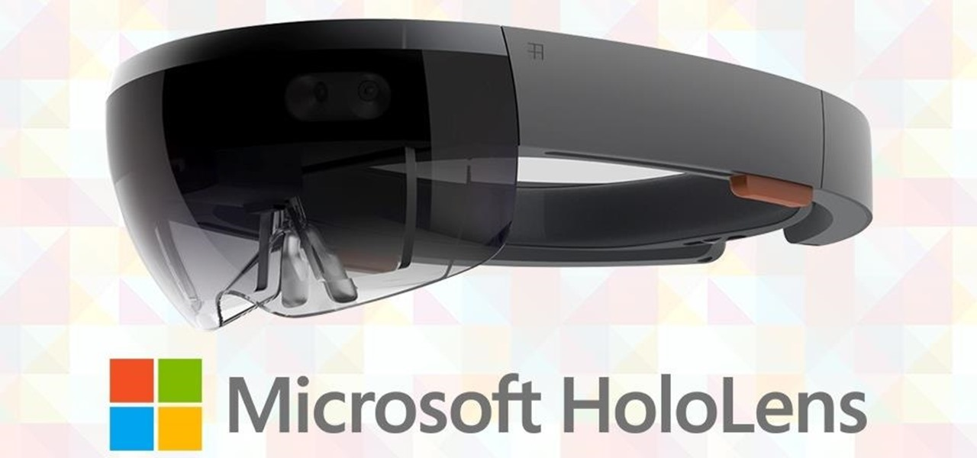
Microsoft HoloLens is the first self-contained, holographic computer, enabling you to engage with your digital content and interact with holograms in the world around you.

known under development as Project Baraboo, is a pair of mixed reality smartglasses developed and manufactured by Microsoft. HoloLens gained popularity for being one of the first computers running the Windows Mixed Reality platform under the Windows 10 operating system. The HoloLens can trace its lineage to Kinect, an add-on for Microsoft's Xbox gaming console that was introduced in 2010.
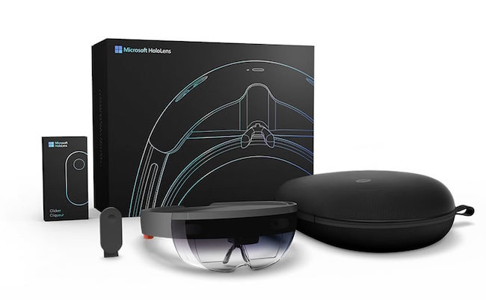
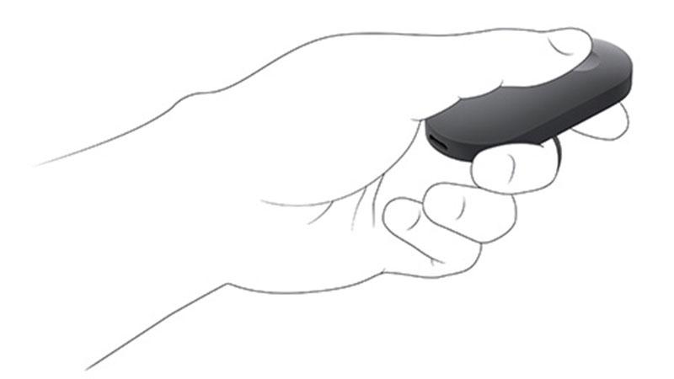
Getting around HoloLens is a bit different from using Windows on other devices. Instead of moving the cursor with a mouse, you use your gaze. And instead of clicking or tapping, you use hand gestures, your voice, or the HoloLens clicker.
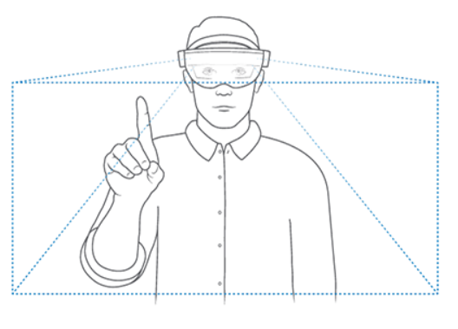

HoloLens emulator
The HoloLens emulator allows you to test holographic apps on your PC without a physical HoloLens and comes with the HoloLens development toolset. The emulator uses a Hyper-V virtual machine. The human and environmental inputs that would usually be read by the sensors on the HoloLens are instead simulated using your keyboard, mouse, or Xbox controller. Apps don't need to be modified to run on the emulator and don't know that they aren't running on a real HoloLens.
Your system must support Hyper-V for the Emulator installation to succeed.
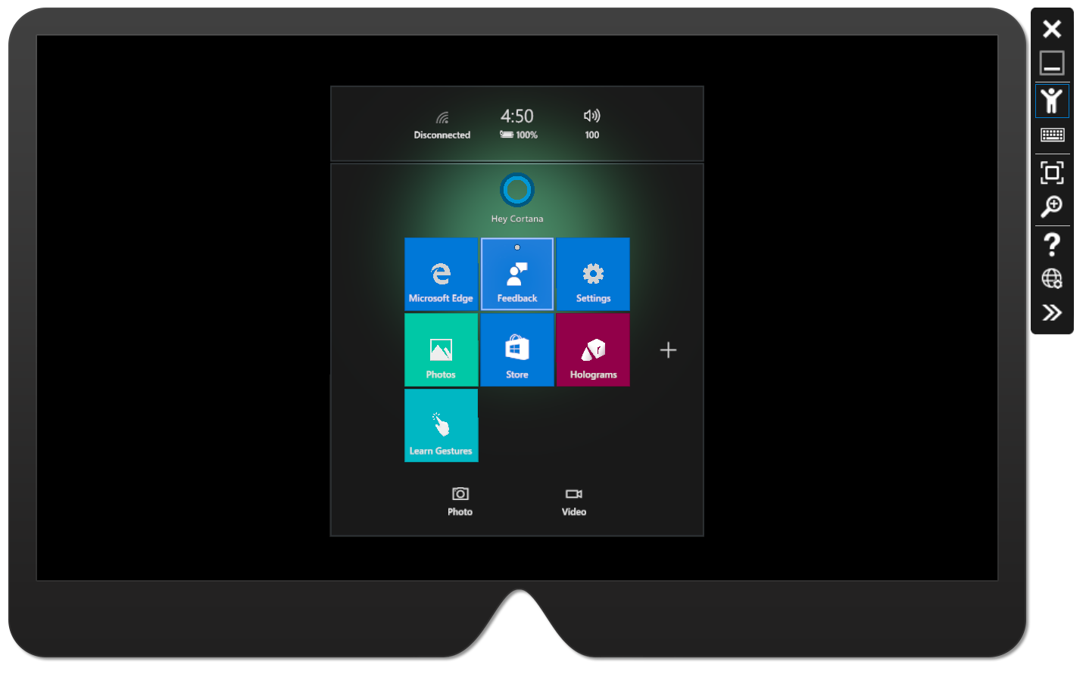

ZXingNet
ZXing is an open source projects, ZXing.Net is a library which supports decoding and generating of barcodes (like QR Code, PDF 417, EAN, UPC, Aztec, Data Matrix, Codabar) within image.
For using Zxing in Unity you can download this example project : https://github.com/mtaulty/QrCodes/tree/master/UnityProject

Features & Screenshots

Read And Send Messages

Once a user logs on to the Hololens App, he can view messages, delete messages and leave messages to other users.
When a user wants to send a message to another user, he needs to scan the QR code of that user.Using a "scan" command, the user can ask the Hololens app to scan a QR code to identify the user he wants to send a message to.
QR identification code execution via Open Source library called ZXing, this library customized to UWP.
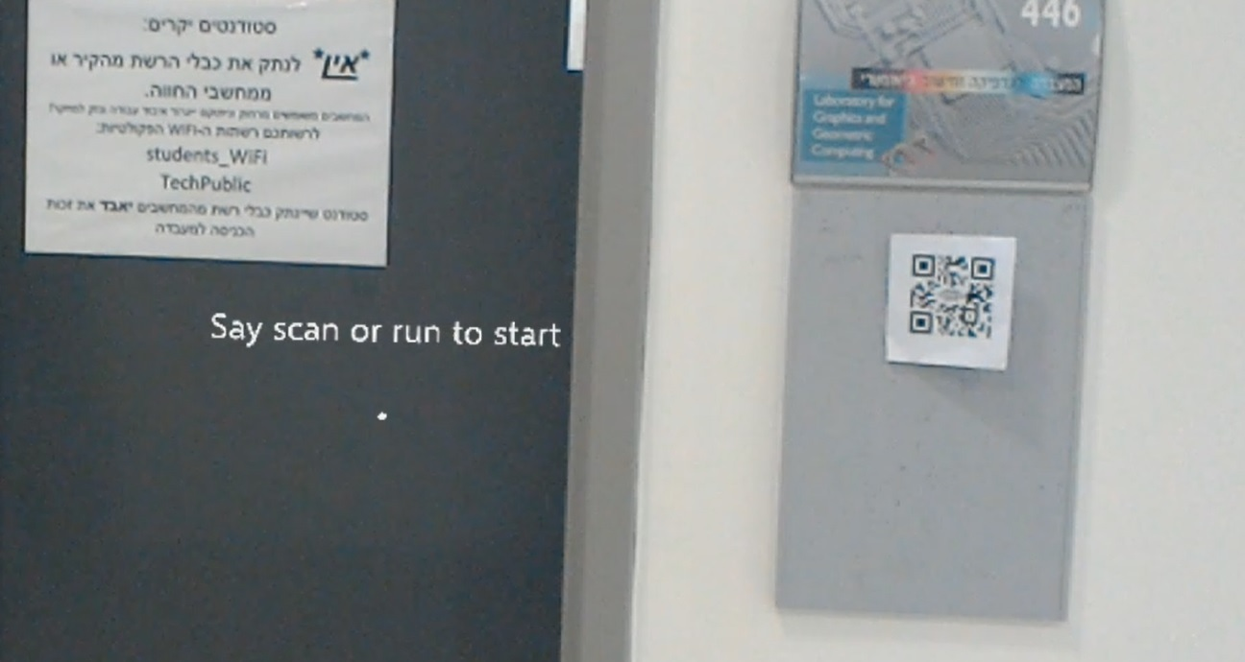

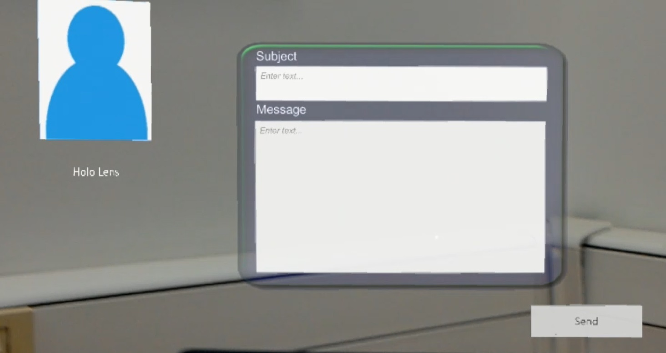

Connect with your smartphone

While HoloLens supports many forms of input including Bluetooth keyboards, most applications cannot assume that all users will have a physical keyboard available. If your application requires text input, on screen keyboard is provided.
But this kind of input might be frastureting.
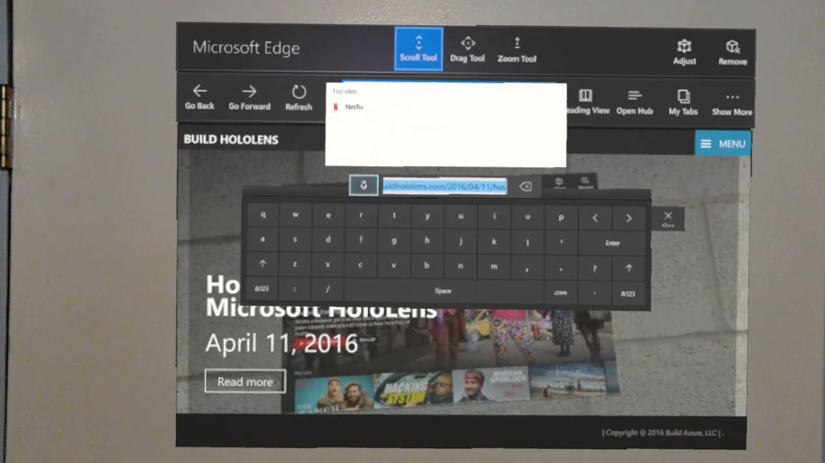
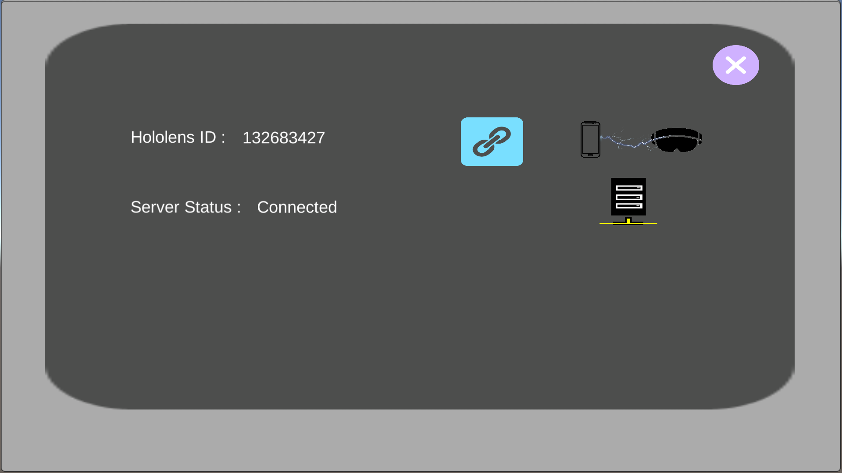
So the user can choose to connect to the Hololens app by registering with a special ID that can be found in the Hololens app, With this option, he can select a text box in the Hololens app and type the text and update it via the smartphone application.

Menu

In the Hololens app there is a dynamic user interface menu that accompanies the user while using the application and allows him to navigate between the various options of the application.

The basic idea is to make it as easy to get to tools as possible, with the user's gaze being the center of the action. If they look at an object, the usable functions for that object appear within close proximity to the gaze cursor. Of course, head locking is a no-no, so we want to avoid that.
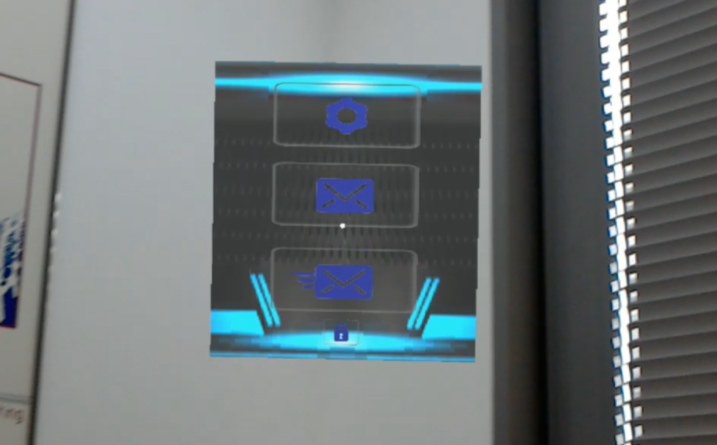
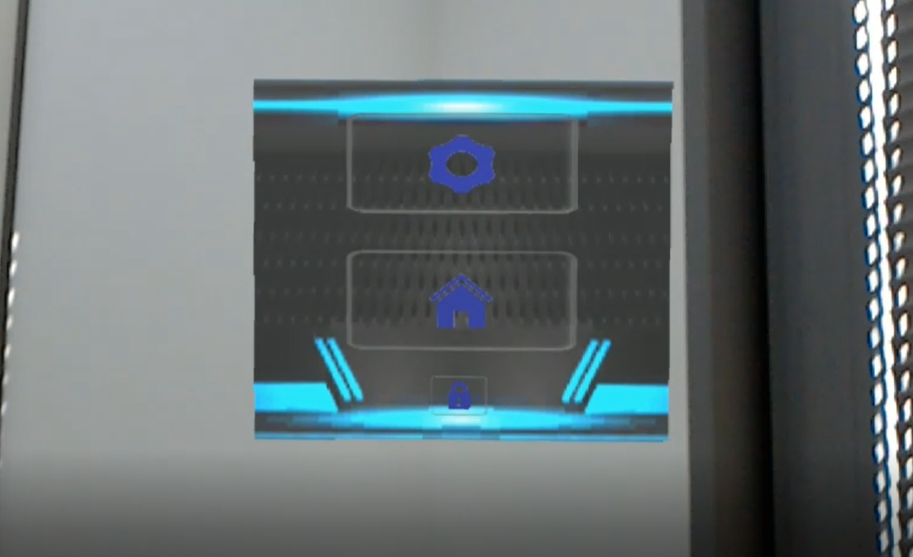
Network

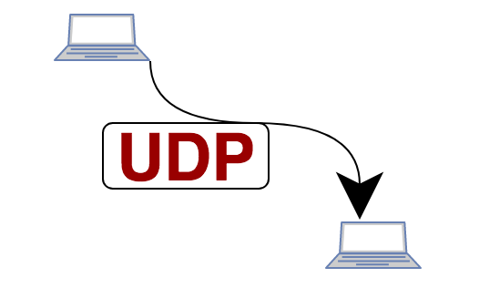
Each system component has a UDP Manager script that manages and sends incoming information, UDP Manager not responsible for information processing or responsible for information content. Its function is to listen to the ports and send information through them.
When information is received, it goes to Network Messages Manager script, which is responsible for assembling network messages and assemble them like a puzzle.

When a network message is complete, it's forwarded for continued treatment. The treatment of the message depends on its purpose.
The server contains two Xml files, one of the files contains users information and images that are encoded into text, and the second contains the messages information that left to users.
Users information and messages Details are managed by the Database Manager script located on the server.

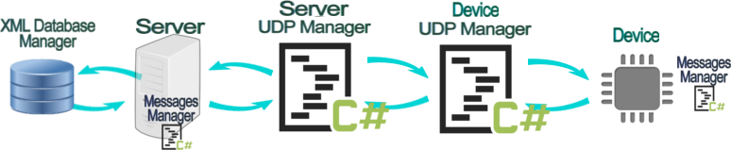

Useful links

Installation checklist for HoloLens
https://docs.microsoft.com/en-us/windows/mixed-reality/install-the-tools
Hololens Gestures
https://docs.microsoft.com/en-us/windows/mixed-reality/gestures
Mixed Reality Academy
https://docs.microsoft.com/en-us/windows/mixed-reality/academy
Performance recommendations for HoloLens apps
https://docs.microsoft.com/en-us/windows/mixed-reality/performance-recommendations-for-hololens-apps
Using the HoloLens emulator
https://docs.microsoft.com/en-us/windows/mixed-reality/using-the-hololens-emulator
ZXing is an open source projects
https://archive.codeplex.com/?p=zxingnet
Example using DatagramSocket
http://talesfromtherift.com/hololens-contest-week-9/
How To Create a UDP Server in C#
https://www.youtube.com/watch?v=cx7LOiQz2jo
UDP and TCP: Comparison of Transport Protocols
https://www.youtube.com/watch?v=Vdc8TCESIg8

