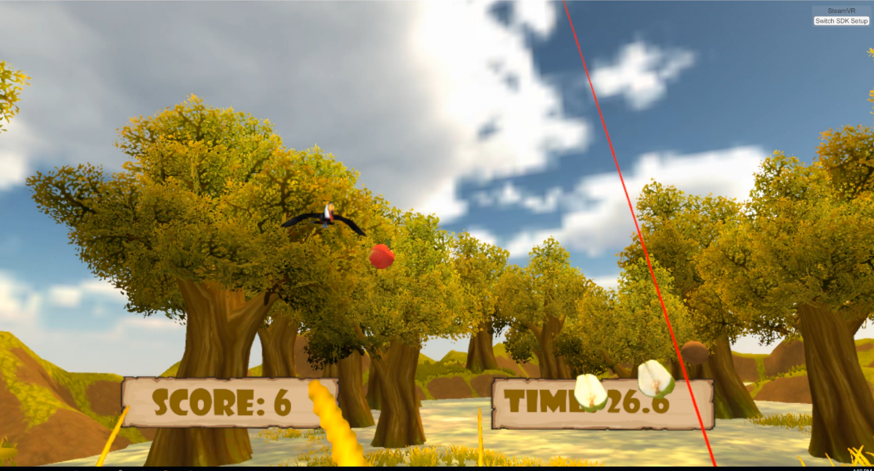
fruit ninga VR

Dror levi and hadar ben efraim

table of contents
Introduction 2
System 3
Application overview 4-5
Development process 6-7
Screenshots 8-12

introduction
We developed a VR game that based on the popular game “Fruit Ninja”. Our application simulates several environments. The player’s main goal is to win as much as points as he can, by cutting fruits and avoiding different obstacles. We added few more functionalities to the game so the player can enjoy both the game and the VR experience. The application gives the player an extraordinary experience that enables him to use several senses in order to get a high score.

System
We created a game that runs on computer and played with VR gear, targeted specifically for the HTC Vive.
The application was developed using Unity 2017.2.0 (64-bit) game engine.
Equipment required
- HTC-Vive Headset
- HTC-Vive controller
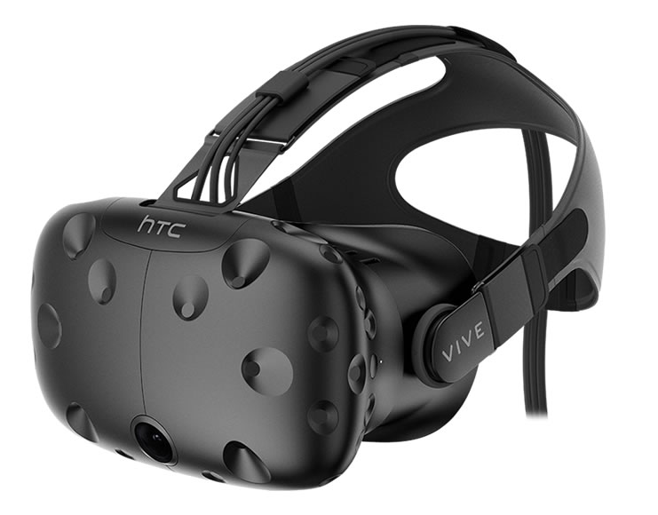
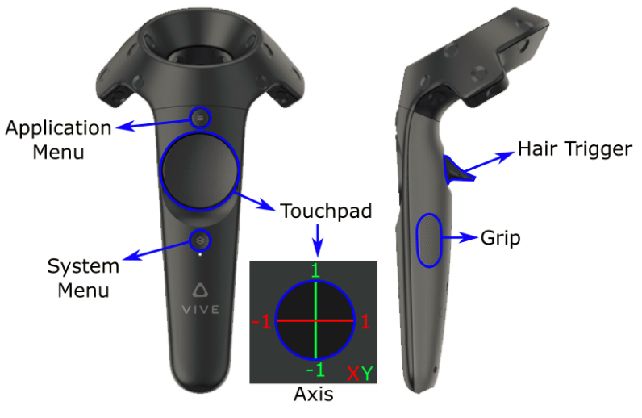

Some relevant links:
https://unity.com/
https://www.raywenderlich.com/149239/htc-vive-tutorial-unity

Application overview
The application consists of 3 scenes for the user to Navigate.
- Menu
- Play scene
- Game Over scene
the Menu scene
The menu scene allows the user to read the game instructions, choose the game environment and the difficulty level. While using the HTC VIVE right controller’s touchpad and trigger, the user can choose the right options for him within the menu.
In the instructions, the user can read about the game rules, the game’s scoring method, and technical instructions, such as how he should be using the HTC VIVE right controller in order to cut the fruits.
The environments possible to choose from are Field, Space and Iceberg. Each environment looks different than the other and has its own challenges. For example, the field environment has hostile flying birds, that do not appear in the other environments.
The difficulty levels the user can choose are easy, medium and hard. The difference between these levels are the frequency that the fruits are thrown, and the number of spawn points the fruits are thrown from.
Sounds were added in the background, when pressing a button and when starting a new game.
the PLAY scene
There are three possible environments to this scene: Field, Space and Iceberg.
In this scene, the user tries to cut as much as fruits as he can in a period of 30 seconds, in order to win maximum amount of points. Each fruit the user cuts, gets him one point. A cut sound is playing when the user cuts a fruit.
In addition to fruits, there are two more objects that are thrown: a clock and a bomb. When cutting a bomb, the user can hear and see an explosion and 3 points are reduced from his score. When a bomb is thrown the user can hear the bomb sound and know he has to be careful. When cutting a clock, the user wins three more seconds to his game. Each time such bonus is hit, a number indicates +3 or -3 is instantiated.
Furthermore, in the field environments the user can also cut flying birds. Each bird he cuts gets him three more points and feathers and chicken legs instantiated. There are 6 different kinds of birds, each with its own special sound.
In the snow environment, there are running penguins that the user can cut, in case he succeeds, he wins three points for a penguin. A bonus sign of +3 appears to let him know of the hit.
The Space scene also contain space shuttles, flying bombers and he can see planet earth.
The user can hear a motivating theme music, hear appropriate noises when a fruit is being cut, a bomb explodes, a bird is being cut etc.
During the game, the user can see how much time has left to the game and his current score.
game over scene
The user can get to this scene only when the game is over (after the 30 seconds of the game). In this scene, the user can see his final score and go back to the game menu.

development proccess
To accomplish our final application, we used unity 2017. We searched online for ways to make unity work with our equipment, the HTC VIVE headset and controllers. We found VRTK- virtual reality tool kit, a productive VR Toolkit for rapidly building VR solutions in Unity3d.
We searched for fruits assets, and sliced fruits assets and after we found some, we started writing the code.
We decided the fruits will be thrown upwards, as they are thrown at the original Fruit Ninja game. Also, in order to achieve a more realistic throw, the throw direction isn’t direct up, the fruits are thrown with an angle and applies to earth physics. We wanted that when a fruit is being cut, the appearance of its sliced version, and the separation of the sliced parts would look as real as possible. In order to do this, whenever the user cuts a fruit, the fruit prefab is replaced by the sliced fruit prefab. The sliced fruit prefab is a combination of two parts of the fruit, close to each other, so together it looks like the original fruit. The sliced parts colliders are overlapping. The overlap creates the effect of the separation of the sliced fruit parts and this way, they are falling in a more realistic way (they act like they just collided each other, therefor they have horizontal velocity). The cut fruit prefab appears at the same rotation as the original fruit was sliced so the slice looks realistic.
The process wasn’t easy. First the cut wasn’t at the right direction, and even when a fruit was thrown, it looked like you see the fruit from the back. It took a lot of work to make the cutting and the falling intuitive and realistic.
in addition, we wanted to make our game special and a little different from the origin, so we added a few extras.
Different environments- we wanted to take advantage of the VR experience to upgrade our game. We decided that the user will choose between three different game environments, which each environment contains different background and objects. For example, the space environment has a few kinds of spaceships that are flying around during the user plays. We made it work by creating a script to the main game scene, that instantiates a game object that contains a group of prefabs according to the environment the user chose.
Flying birds (or at the iceberg environment – running penguins) – we added another option of winning points – cutting birds (or penguins). These objects are instantiating in a random rate (in a certain range of time). In a similar way to the fruits, when the user points at these objects with the right controller, their prefab changes to a “dead bird’s legs” prefab and falls down as a rigid body. In addition, when the “dead bird’s legs” instantiates, there is a sound (configured – on awake) of a bird.
Different sounds – we wanted that while the user is playing, he will feel like he is totally disconnected from the real world, and that he is living the game. We thought the sounds can attribute to this idea. There is a background music at each scene (made by adding a component of the sound and configured – on awake), when the user cuts a fruit there is an appropriate sound, when a bomb is thrown into the game there is a burning thread’s sound and when the user cuts it and the bomb explodes, there is an explosion sound. In addition, as we mentioned before, when the user cuts a bird (or a penguin) there is a bird sound. All of the sounds are taken from online sources we found on google.
For conclusion, our main challenges during the process was to make the fruits (and the exploding bombs) look as real as possible, especially when cutting them. We tried to make the game interesting and intractable, by adding more features to the game and to adjust existing and new features to the VR experience.

screen shots
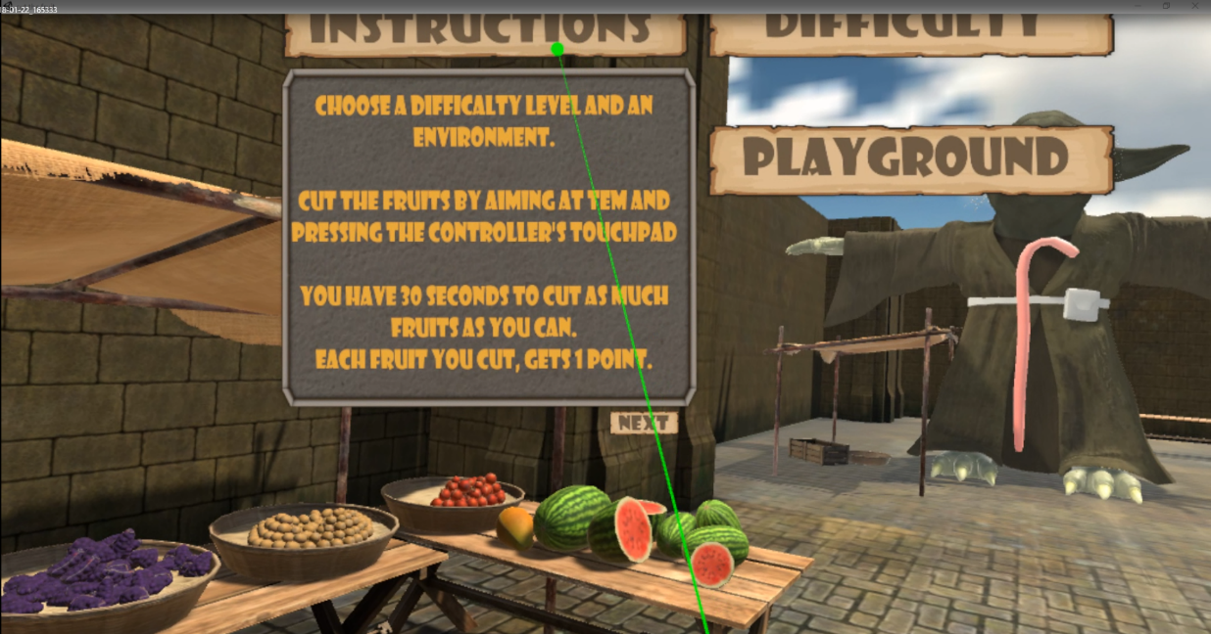
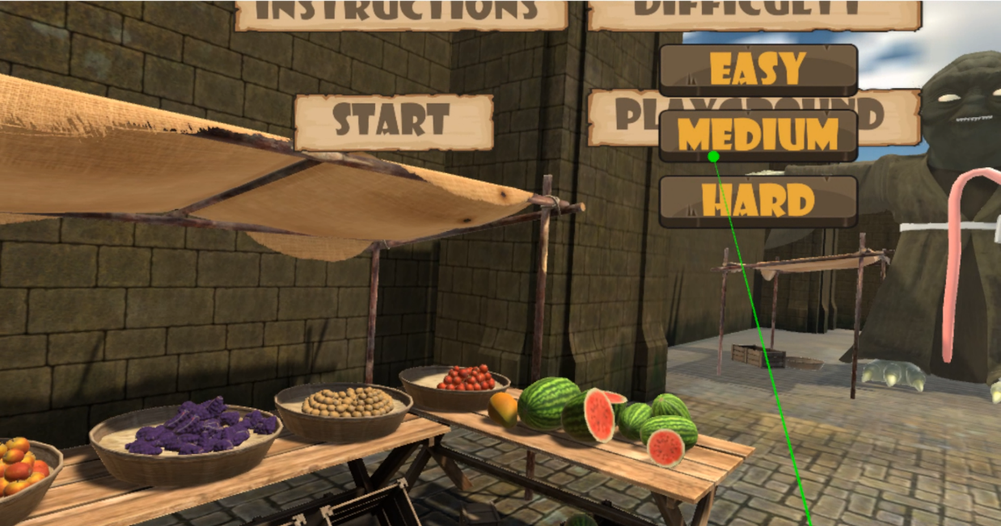
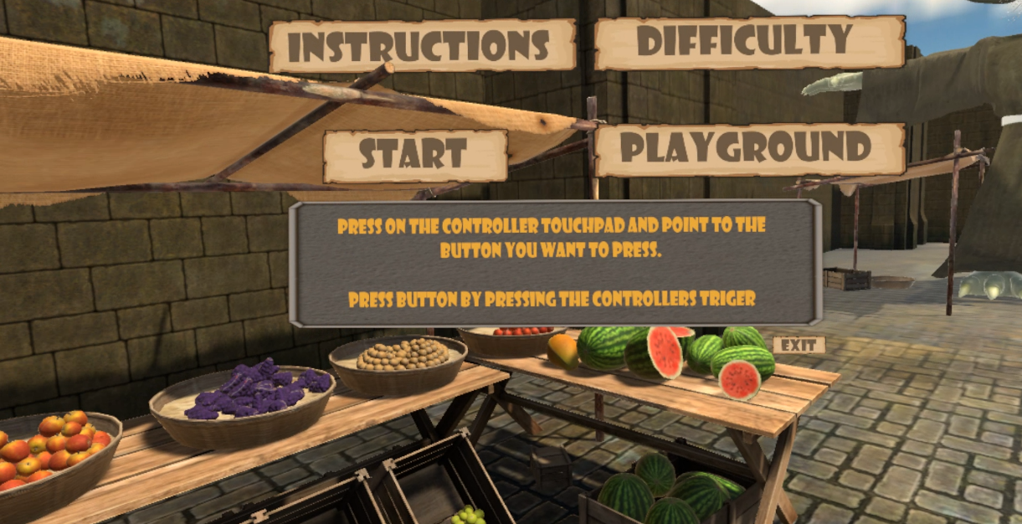
the menu scene
The game scene – field playground
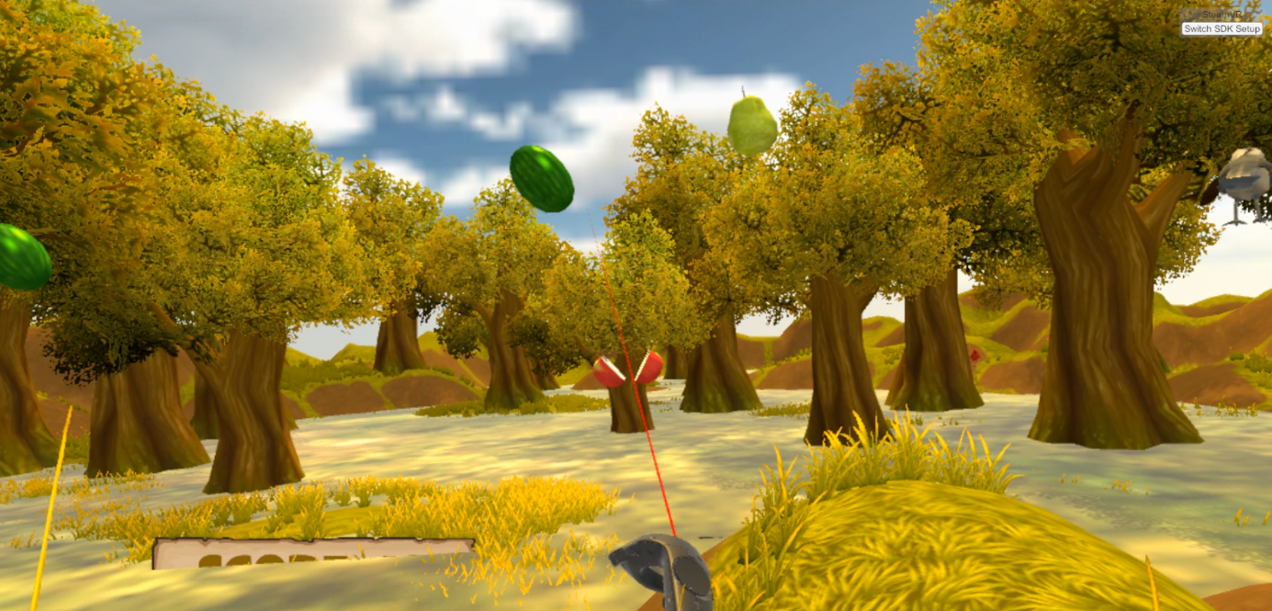
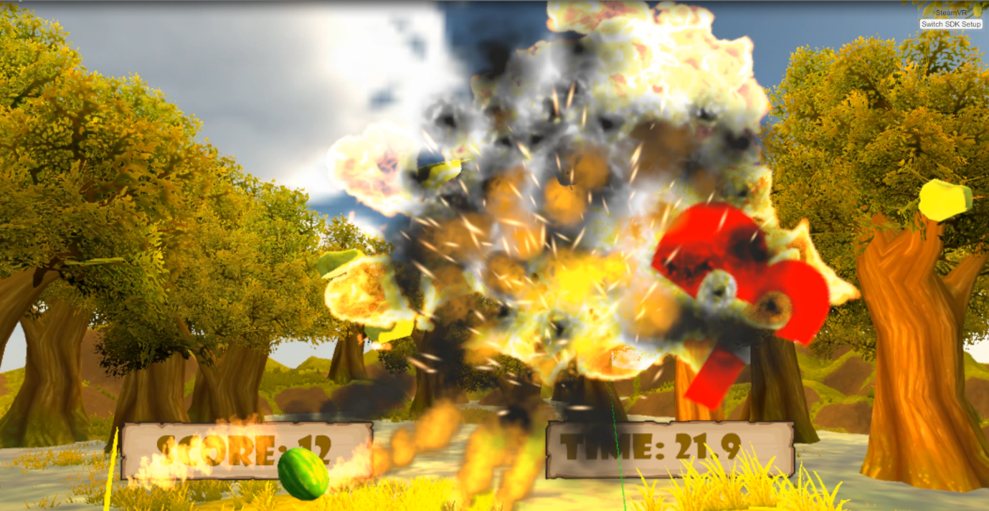
The game scene – iceberg playground
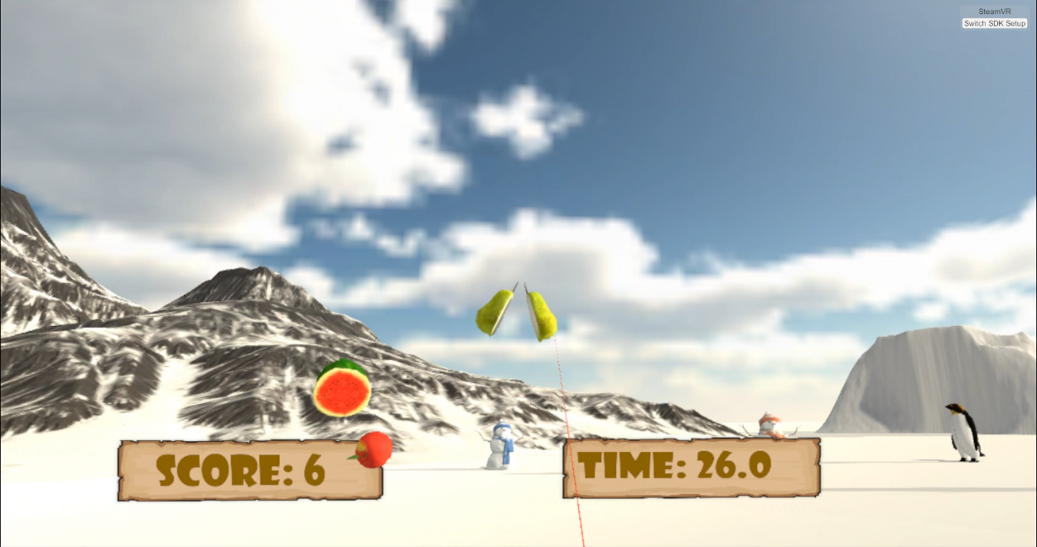
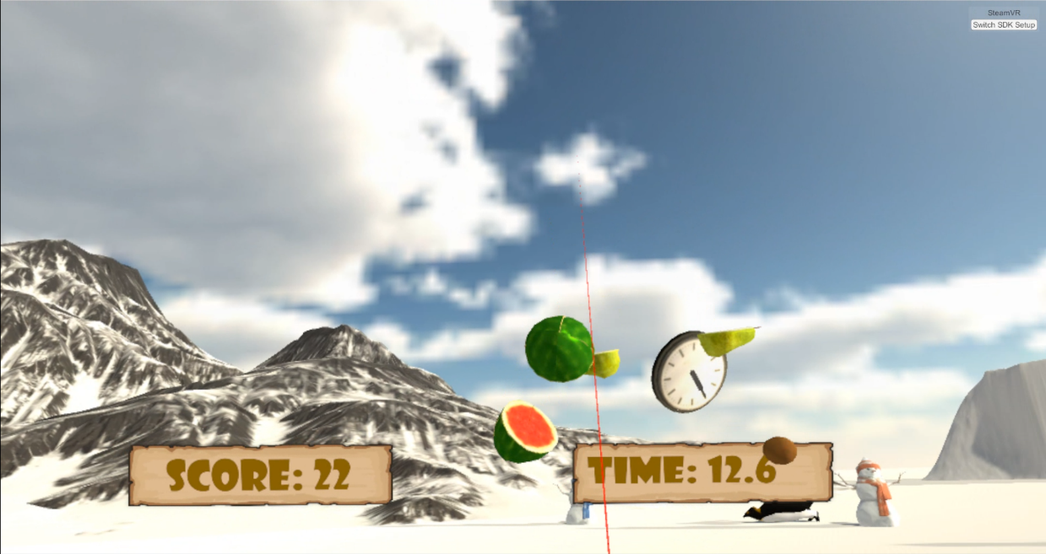

The game scene – space playground

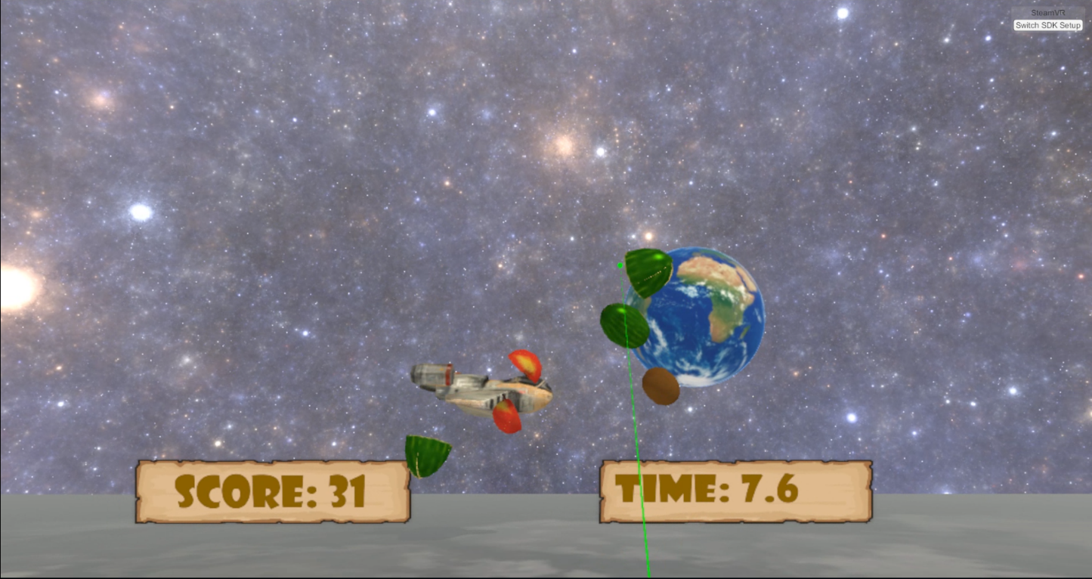
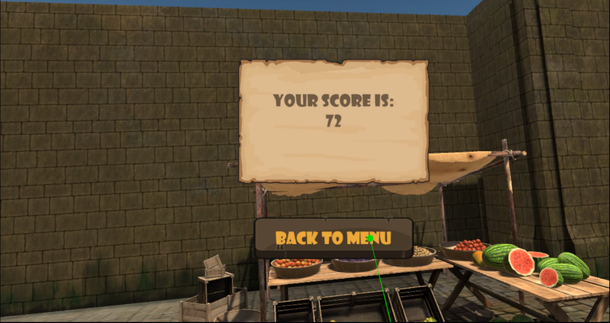
The game over scene

